Contents

Libraries/Packages: 2

Setting up Virtual Environment for Validator: 2

How to use the validator: 3

Flowchart: 4

Requirements.txt 5

# Libraries/Packages:

|  |  |  |  |  |  |  |
| --- | --- | --- | --- | --- | --- | --- |
| Sr. no. | Name | Version  Used | Current  Version | License | Approval  Status | Publications  Fullfilments |
| 1 | Pip | 22.1 | 22.1 | MIT |  |  |
| 2 | Python | 3.9.12 | 3.10.4 | BSD 0 Clause |  |  |
| 3 | Guesslang | 2.2.1 | 2.2.1 | MIT |  |  |
| 4 | numpy | 1.22.3 | 1.22.3 | BSD 2 Clause |  |  |
| 5 | pandas | 1.4.2 | 1.4.2 | BSD 3 Clause |  |  |
| 6 | Setuptools | 62.1.0 | 62.1.0 | MIT |  |  |
| 7 | Tensorflow | 2.5.0 | 2.8 | Apache License 2.0 |  |  |

# Tools:

|  |  |  |
| --- | --- | --- |
| Sr.  No. | Name | Version |
| 1 | Anaconda | 4.10.3 |
| 2 | VScode | 1.67.0 |

# Setting up Virtual Environment for Validator:

Instructions for setting up virtual environment for Validator are given below:

1. Download anaconda:

|  |
| --- |
| <https://docs.anaconda.com/anaconda/install/windows/> |

And follow all the steps in the given link

|  |
| --- |
| <https://www.python.org/downloads/> |

1. Download Python:

And don’t forget to check the checkpoint (Add path variable) after opening the .exe of python

1. Type anaconda in Windows search bar and open the anaconda prompt
2. Create new virtual environment on anaconda by typing this command:

*conda create -n myenv*

[myenv: is the name of virtual environment, it can be anything]

1. Activate the Environment using the command as follows.

*conda activate myenv*

[myenv in the name of virtual environment]

1. Install the following libraries, by using same sequence of commands as given below:
2. pip install tensorflow
3. pip install guesslang
4. pip install pandas
5. pip install setuptools
6. Now to go VS code and open the .py file
7. There’s an option in Bottom right corner of VS for selecting the python Interpreter of python virtual environment to execute the code
8. Select the Python interpreter named as same as your Virtual Environment name
9. Click on the Run button and click start without debugging

# How to use the validator:

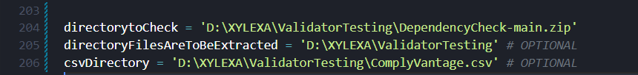

Set these Variable names:

**directorytoCheck:** zipped folder to unzip and apply validation on it

**directoryFilesAreToBeExtracted:** (Optional) Mention the folder name where you want to extract the files of zipped folder. Default value is *“directorytoCheck”* root folder

**csvDirectory:** (Optional) Mention the folder name where CSV should be generated.

# 

# Flowchart:

|  |
| --- |
| <https://lucid.app/lucidchart/7f9a3570-e732-4d4c-ab47-6d4d1b8ce21d/edit?invitationId=inv_eff5e99c-a3fd-4365-a006-19771b697e01> |

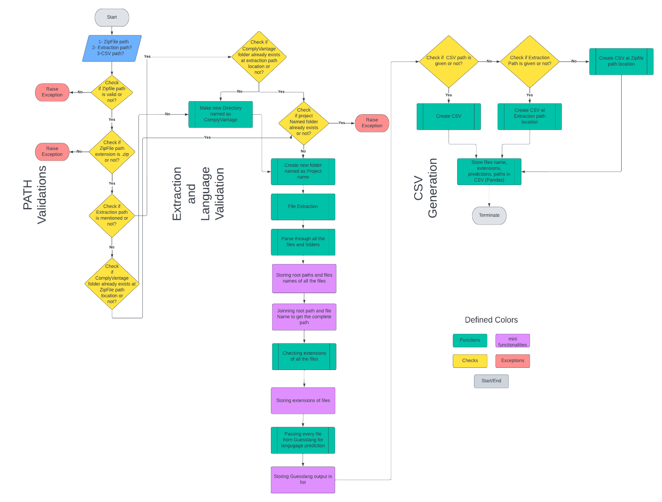

# Requirements.txt

|  |
| --- |
| absl-py @ file:///opt/conda/conda-bld/absl-py_1639803114343/work  aiohttp @ file:///C:/ci/aiohttp_1646806572557/work  aiosignal @ file:///tmp/build/80754af9/aiosignal_1637843061372/work  astor==0.8.1  astroid==2.4.2  astunparse==1.6.3  async-timeout @ file:///tmp/build/80754af9/async-timeout_1637851218186/work  attrs @ file:///opt/conda/conda-bld/attrs_1642510447205/work  blinker==1.4  brotlipy==0.7.0  cachetools @ file:///tmp/build/80754af9/cachetools_1619597386817/work  certifi==2021.10.8  cffi @ file:///C:/ci_310/cffi_1642682485096/work  charset-normalizer @ file:///tmp/build/80754af9/charset-normalizer_1630003229654/work  clang==5.0  click @ file:///C:/ci/click_1646038595831/work  colorama==0.4.4  cryptography @ file:///C:/ci/cryptography_1633520531101/work  docopt==0.6.2  flatbuffers==1.12  frozenlist @ file:///C:/ci/frozenlist_1637767271796/work  gast @ file:///Users/ktietz/demo/mc3/conda-bld/gast_1628588903283/work  google-auth==1.35.0  google-auth-oauthlib==0.4.1  google-pasta @ file:///Users/ktietz/demo/mc3/conda-bld/google-pasta_1630577991354/work  grpcio==1.34.1  guesslang==2.2.1  h5py==3.1.0  idna @ file:///tmp/build/80754af9/idna_1637925883363/work  importlib-metadata @ file:///C:/ci/importlib-metadata_1648562621412/work  isort==5.7.0  keras==2.8.0  keras-nightly==2.5.0.dev2021032900  Keras-Preprocessing @ file:///tmp/build/80754af9/keras-preprocessing_1612283640596/work  lazy-object-proxy==1.4.3  Markdown @ file:///C:/ci/markdown_1614364082838/work  mccabe==0.6.1  mkl-fft==1.3.1  mkl-random @ file:///C:/ci/mkl_random_1626186184308/work  mkl-service==2.4.0  multidict @ file:///C:/ci/multidict_1607349747897/work  numpy==1.22.3  oauthlib @ file:///opt/conda/conda-bld/oauthlib_1644332107998/work  opt-einsum @ file:///tmp/build/80754af9/opt_einsum_1621500238896/work  pandas==1.4.2  pathlib==1.0.1  protobuf==3.14.0  pyasn1 @ file:///Users/ktietz/demo/mc3/conda-bld/pyasn1_1629708007385/work  pyasn1-modules==0.2.8  pycparser @ file:///tmp/build/80754af9/pycparser_1636541352034/work  PyJWT @ file:///C:/ci/pyjwt_1619682721924/work  pylint==2.6.0  pyOpenSSL @ file:///tmp/build/80754af9/pyopenssl_1635333100036/work  pyreadline==2.1  PySocks @ file:///C:/ci/pysocks_1605307512533/work  python-dateutil==2.8.2  pytz==2022.1  requests @ file:///opt/conda/conda-bld/requests_1641824580448/work  requests-oauthlib==1.3.0  rsa @ file:///tmp/build/80754af9/rsa_1614366226499/work  scipy @ file:///C:/ci/scipy_1641555170412/work  six==1.15.0  tensorboard @ file:///tmp/build/80754af9/tensorboard_1633093581375/work/tensorboard-2.6.0-py3-none-any.whl  tensorboard-data-server @ file:///C:/ci/tensorboard-data-server_1633035225228/work/tensorboard_data_server-0.6.0-py3-none-any.whl  tensorboard-plugin-wit==1.6.0  tensorflow==2.5.0  tensorflow-estimator==2.5.0  termcolor==1.1.0  toml==0.10.2  typing-extensions==3.7.4.3  urllib3 @ file:///opt/conda/conda-bld/urllib3_1643638302206/work  Werkzeug @ file:///opt/conda/conda-bld/werkzeug_1645628268370/work  win-inet-pton @ file:///C:/ci/win_inet_pton_1605306162074/work  wincertstore==0.2  wrapt==1.12.1  yarg==0.1.9  yarl @ file:///C:/ci/yarl_1606940155993/work  zipp @ <file:///opt/conda/conda-bld/zipp_1641824620731/work>  Default value is *“directoryFilesAreToBeExtracted”* (if provided), else *“directorytoCheck”* root folder |